**Agile software development using JIRA**

**Arun Avinash Chauhan**

**Introduction:**

What is Agile software development?

Agile software development methodologies are all about delivering small pieces of working software quickly to improve customer satisfaction (while building software iteratively). These methodologies use adaptive approaches and teamwork to focus on continuous improvement. [[1](https://www.redhat.com/en/devops/what-is-agile-methodology#:~:text=In%20practical%20terms%2C%20agile%20software,to%20focus%20on%20continuous%20improvement.)]

The four principles of Agile development [[2](https://business.adobe.com/blog/basics/agile-manifesto)] are:

1. Individuals and interactions over processes and tools.
2. Working software over comprehensive documentation.
3. Customer collaboration over contract negotiation.
4. Responding to change over following a plan.

*Agile software development* is a philosophy, whereas *scrum* is a framework that helps fulfill the philosophy or idea of Agile development. Jira is a software (SaaS) that helps implementing a scrum.

What is scrum project?

Scrum (or scrum project) is one of the most popular frameworks for implementing Agile. With scrum, the product is built in a series of fixed-length iterations called sprints that give teams a framework for shipping on a regular cadence (or time interval) [[3](https://www.atlassian.com/agile/tutorials/how-to-do-scrum-with-jira-software)]

What is an issue?

In Jira Software, we call work items like user stories, tasks, and bugs, "issues"

But what are user stories, tasks and bugs?

User stories are used to **describe work items in a non-technical language** and from a user’s perspective. As a {type of user}, I want {goal} so that I {receive benefit}. Once you've created a few user stories, you can start prioritizing them in the *backlog* (a certain section of JIRA software). Over the project lifetime, you can modify user stories and add new user stories [[3](https://www.atlassian.com/agile/tutorials/how-to-do-scrum-with-jira-software)].

Tasks are any work items that are to be performed by various team members of a project

Bugs are functional anomalies that are logged down so that they can be tracked to completion – whether the bug has been fixed and tested for non-existence.

Finally, what is a Sprint?

In Scrum, teams forecast to complete a set of user stories or other work items during a fixed time duration, known as a sprint. Generally speaking, sprints are one, two, or four weeks long. It is generally recommended that sprints be two weeks long, which gives enough time to get some work done, and yet quick enough to get feedback on where the project is headed and how well it is going.

**Step by step procedure to run Agile project development using a scrum project**

Prerequisite: Jira software account. Get a [free Jira account here](https://www.atlassian.com/software/jira/free)

Getting a Jira account:

On clicking the link, you will come across a set of steps which are self-evident. However, when selecting the type of work you want to do, it is suggested you use ‘Software Development’. Once you do so, you have an option to begin right away with a ‘Scrum project’. You are allowed to have a free account which can support up to 10 users. Create an account using Google or your work email. **IMPORTANT: Use your roll number as password - so that it can be shared with me (I will need to login to your Jira project to check scrum project setup to evaluate assignment)**

Once you have successfully created your account, you will be asked to create a domain / site within Atlassian.com. Give any name you would like (provided it is available). You can choose to tell a little bit about yourself.

Give a name for your scrum project, go to more project templates and select ‘scrum project’. By default, the template might be ‘Kanban project’. Therefore, go to ‘More project templates’ and choose ‘Scrum project’.

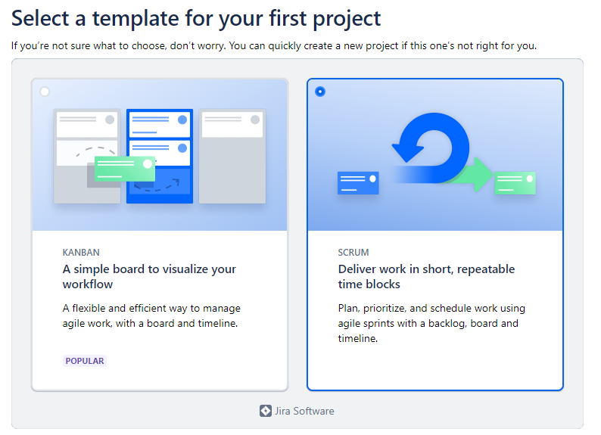

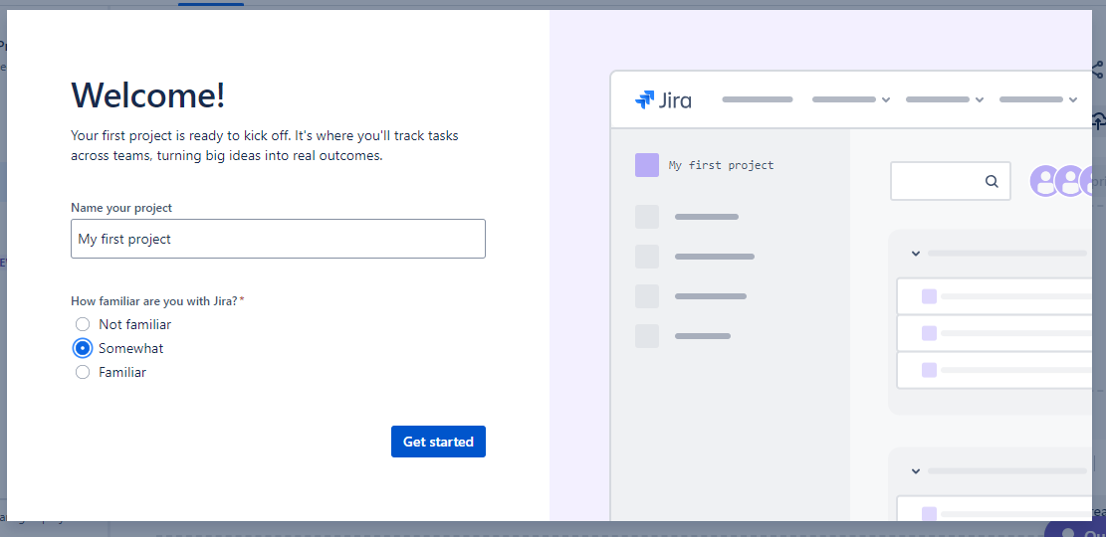

At this point, you are taken to your scrum project landing page. This page is called ‘Backlog’. It is recommended that you take a tour that Jira provides. This tour will show you how to do some basic tasks related to management of a scrum project (and your assignment) - SEE QUICKSTART to the right of your screen

You can either continue reading this document to finish your assignment related tasks, or you can play around / explore the scrum project at the Atlassian website that runs Jira and complete the assignment related tasks. The following image shows your landing page once the project has been created.

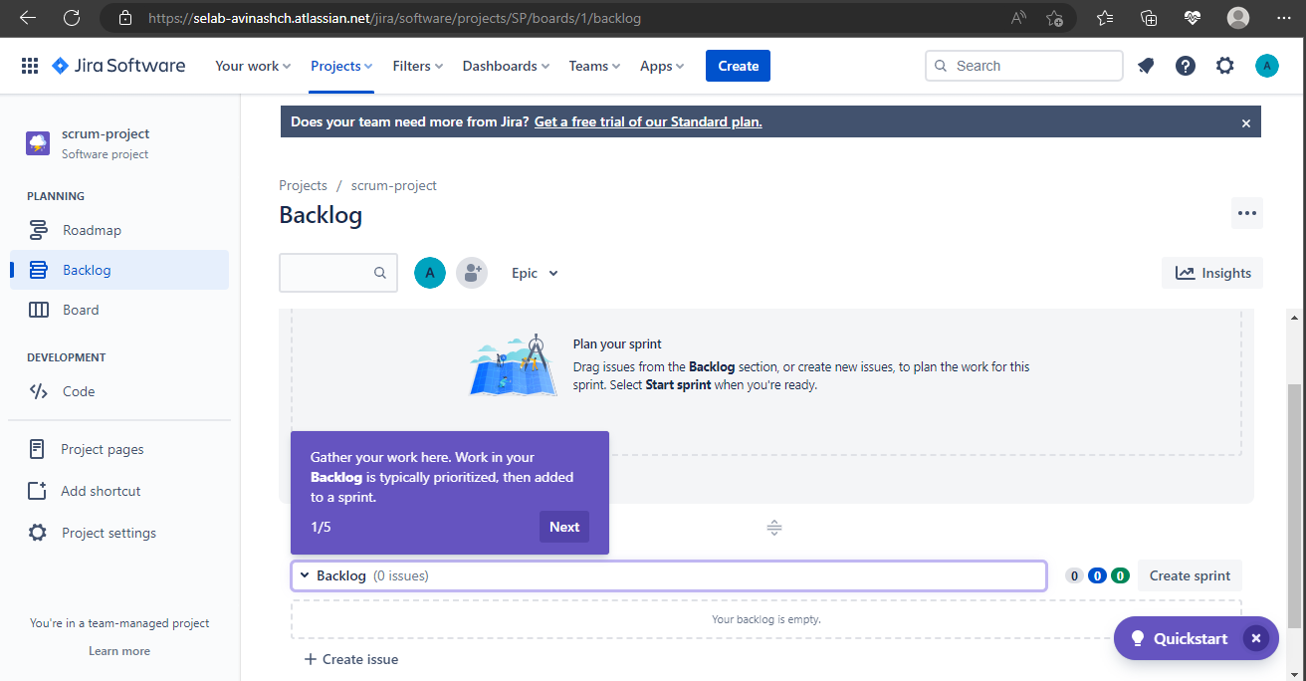

Create Issues and Sprint:

Your issue can be a project task, support ticket, request form, or any other unit of work relevant to your project. For now, think of an issue as a user story. Either select ‘+ create issue’ in ‘backlog’ or select ‘Create’ from the pane on top. **A window pops up**. Using drop downs, select the project to which the issue belongs, and the type of the issue – either *Story, Task, Bug or Epic1.*

Coming back to our task at hand. Create an issue. Select ‘Story’ as issue type. Assign the task to someone (for now, you are the only person in this project so assign it to yourself).

The issue (task) can be assigned to a ‘Sprint’. Since we started with creation of ‘issue’ first, we do not have any ‘Sprint’ but Jira provides a default Sprint – Sprint1. I went ahead and selected ‘Sprint 1’ and that way, this created ‘issue’ (Story) goes and sits inside the Sprint (issue must be worked on in Sprint 1).

‘Story point estimate’ gives an idea of the complexity of the work item and is a numerical scale. Give it a value 1

‘Reporter’ is the person who is creating this ‘issue’.

‘Linked issue’ - An issue (in this case our Story) can be linked (dependent) on other issues. Right now, we have just one issue but in case our project has multiple issues, you can link an issue to another issue (Example: A story called ‘Website implementation’ can be linked to an issue called ‘Website design’, with Website design happening first and Website implementation following after). At this point (after creation of first issue), this is how your dashboard (the backlog page) looks like:

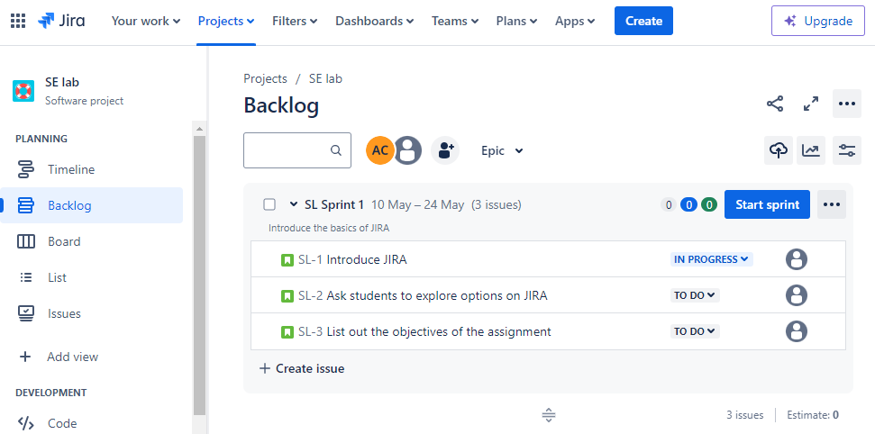

Go ahead and 1) create one more issue (perhaps another story), 2) link this issue to the previous issue, and then 3) ‘add dates’ to the sprint and 4) select ‘Start sprint’ option. The pop ups that come up when you click ‘add dates’, and when you click ‘Start sprint’ are pretty self-explanatory. Note – Give a two-week work window for the Sprint. Once you do these steps and hit ‘Start sprint’, the backlog page will look like this.

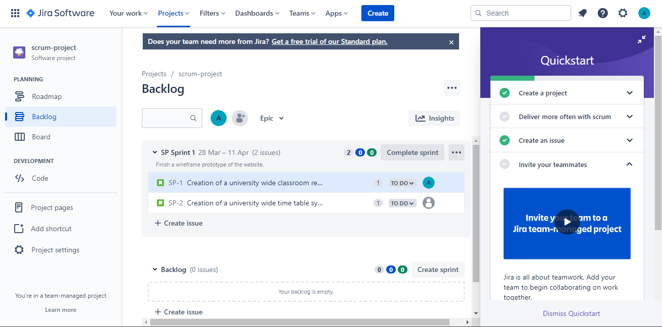

Notice the ‘Quickstart’ panel to the right? This panel is available at every section (Roadmap, Backlog and Board). This is one easy way of working with Jira. You can use this ‘Quickstart’ guide to complete your tasks (if you would like so).

Once you hit ‘Start sprint’, the ‘Board’ page is populated as follows:

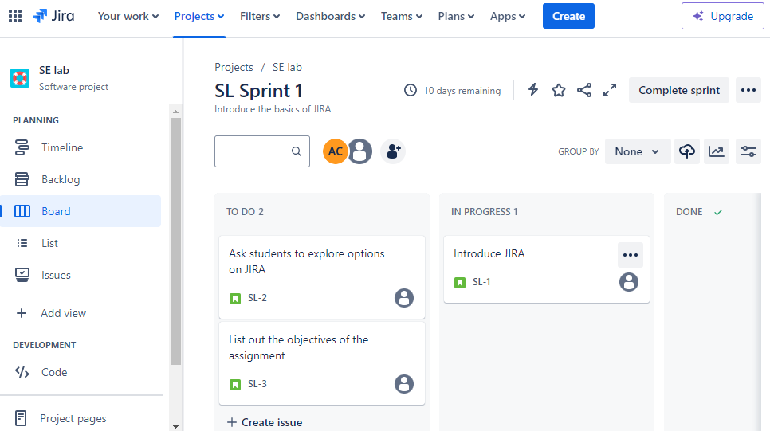

Next, go back to ‘Backlog’ page, use the ‘Quickstart’ guide to invite teammates to your scrum project. Use the ‘Quickstart’ guide to invite your teammates (via email). Assign one of the issues (stories) to the invited teammate (Assignee).

Note: To assign a ‘story’ (basically make changes to a story / task / bug), all you need to do is click the ‘story’ (or task or bug) and a little window pops up (see screenshot below), wherein you can make changes to your existing ‘story’ (or task or bug), like assign the ‘story’ to someone, or change other properties of the ‘story’.

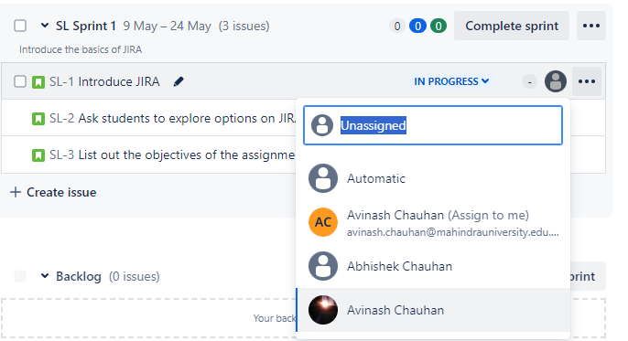

Linking an issue:

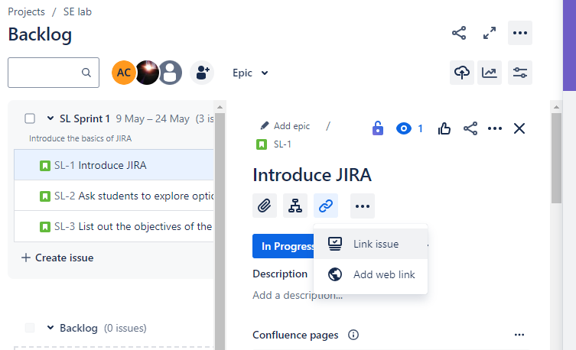

Create an Epic:

Your team may need to work on features that comprise of a larger body of work. When this happens, you should consider using epics when planning your work and grooming the backlog. Epics are essentially large user stories that you can break down into smaller user stories, or a group of user stories (or issues).

Goto ‘Roadmap’ > Select ‘Create Epic’ > Name it something you like, perhaps ‘Website Development’ > Then go back to ‘Backlog’ and select ‘+ Epic’ next to the story and assign both stories to newly created ‘Epic’ > Go back to ‘Roadmap’, now you can see both your stories under the ‘Epic’ you created, along with a Gantt chart like representation of the time needed to complete the stories. There is also a link between the two stories showing the dependency between the stories (or issues). See screenshot below.

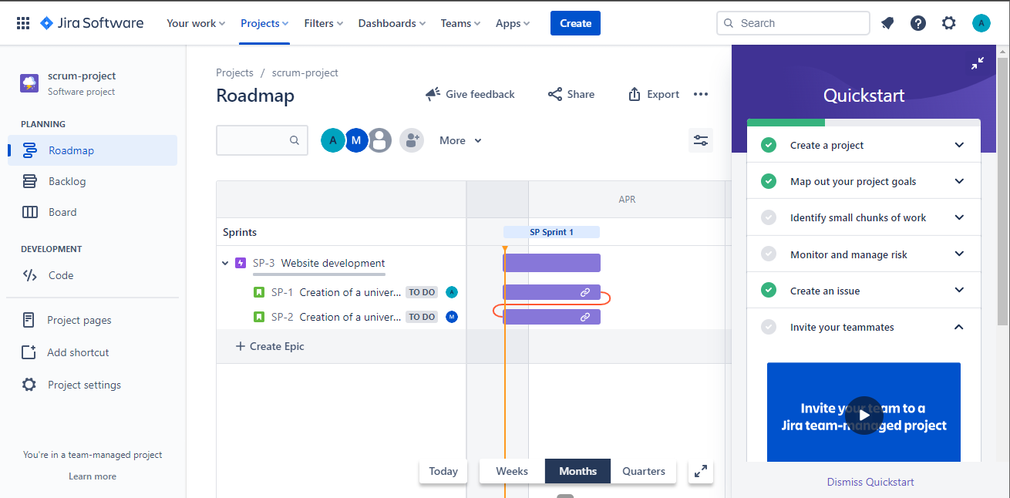

Link GitHub to your scrum project:

Goto ‘Code’ from the left panel, scroll down till you come across ‘Github for Jira’ at the Atlassian marketplace > Install > Configure App > Connect ‘Git Hub Organization’ > Select ‘GitHub Cloud’ > Provide Github credentials > Select ‘Connect’ > It shows connecting status (it took me around 5 minutes, after which I hit page refresh whereupon it showed backfill status ‘Finished’) > Once it connects successfully to GitHub, it shows in the ‘Code’ section as follows (see image below)

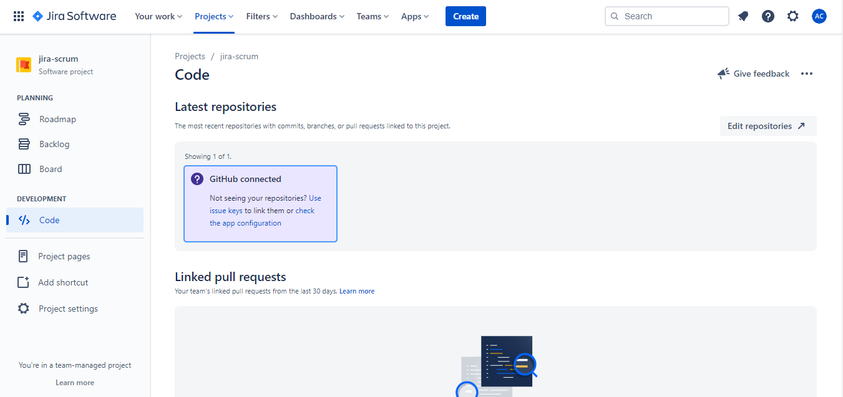

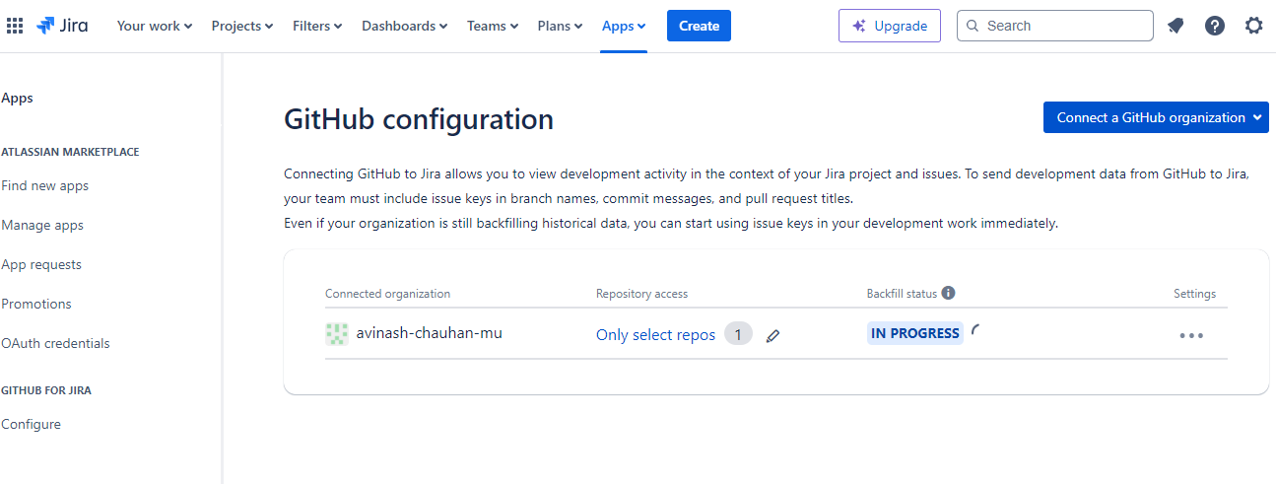

Once you have your GitHub linked to your JIRA scrum project, you will be able to create branches in your Github corresponding to your ‘story’ (your work item) and track your coding task in sync with your ‘story’ (or work item).

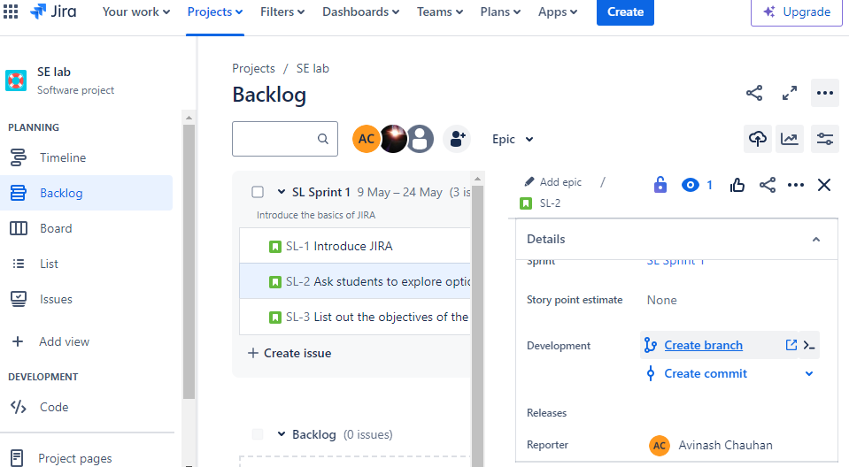S

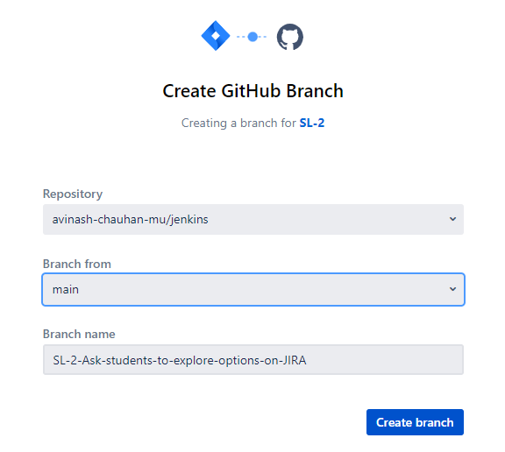

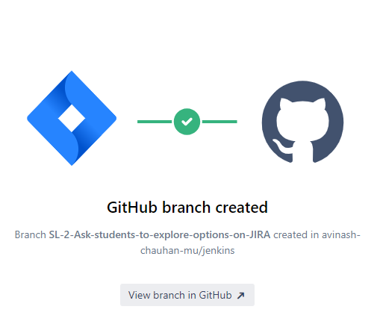

**Note:**  
Reference JIRA Issues in Commit Messages:

When you make changes to your code and commit them to your GitHub repository, include the JIRA issue key in your commit message.

For example, if your JIRA issue key is "PROJ-123," your commit message could be: "Fix issue PROJ-123: Updated the login page layout."

Automatic Integration (Optional):

Some JIRA-GitHub integrations offer automatic linking of commits to JIRA issues based on the presence of the issue key in the commit message. Check if your integration supports this feature.

View Commits in JIRA:

After committing code to GitHub with JIRA issue keys in the commit messages, you should see these commits linked to the corresponding JIRA issues.

In your JIRA project, navigate to the specific issue that was referenced in the commit message.

Under the "Development" or "Activity" tab, you should see the commits associated with the issue.

**Assignment:**

1. Create a scrum project using JIRA software (10 marks)
   1. Create a JIRA account
   2. Create a scrum project [1 M]
   3. Create four issues (stories) [2 M]
   4. Create a sprint consisting of three issues (stories) and another sprint of one issue [1 M]
   5. Create a link (dependency) between two issues [1 M]
   6. Add a team member to your scrum project, assign one issue to team member [2 M]
   7. Link your Github account to your scrum project [2 M]
   8. Create a branch via JIRA which links that branch to a JIRA issue (work item) [1 M]

Hints:

1. Play around the various options present in your Jira software (SaaS)
2. Use the ‘Quickstart’ guide if need be (read as USE IT!)
3. Tutorial: <https://www.atlassian.com/agile/tutorials> (all tutorials under scrum)

NOTE: While creating your Jira account, use your roll number as a password (since you will have to share your password with me). While evaluating your assignments, I will use your Jira username (or email) and password to login and check if the required items have been created. Reasons for this will be explained in class.